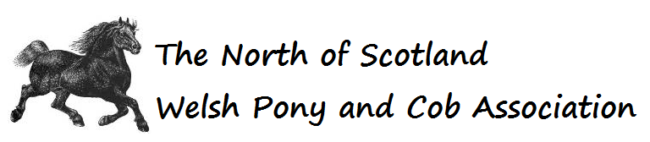
2024 ADVERTISING ORDER FORM

Name: |  |  | Phone:
Email:
Name of Business:
Type of Business:
Signature: |  |  | Date:

Selected show | Spring | Summer Medal | Winter
Date of show

We accept advertising from all trades and businesses which does not need to be horse related.
We hold 3 shows per year offering multiple opportunities
The cost is £15 per advert which will be printed in our schedule, catalogue and published on our website for 3 months.
Take out advertising x 3 and your advert will be listed on our website for 12 months in addition to the above

Please make payment by bank transfer to The North of Scotland WPCA Clydesdale Bank A/C 70120041 S/C 82 65 21
(use your name as a reference)

COPY OF YOUR ADVERT HERE Alternatively forward by email to info@nswpca.co.uk together with this form.

Please note the information you provide will be processed in accordance with our Privacy Policy which may be viewed on our website.
If you require further information, please visit www.nswpca.co.uk or info@nswpca.co.uk

